**Project Plan**

***TickieSystem***

*Invividual Project-*

*Semester III*

|  |
| --- |
| **Date : 06.11.2020** |
| **Version : 2.0** |
| **State : Unfinished** |
| **Author : Aleksandar G** |

#### Version history

|  |  |  |  |  |
| --- | --- | --- | --- | --- |
| **Version** | **Date** | **Author(s)** | **Changes** | **State** |
| V 1.0 | **08.10.2020** | **Aleksandar G** |  | **Unfinished** |
|  |  |  |  |  |
|  |  |  |  |  |

Contents

1. Architectural Design 5

2. Database Design 6

3. Design Desicions 7

3.1 Back-end Framework 7

3.2 Front-end Framework 7

4. Wireframes 8

# Architectural Design

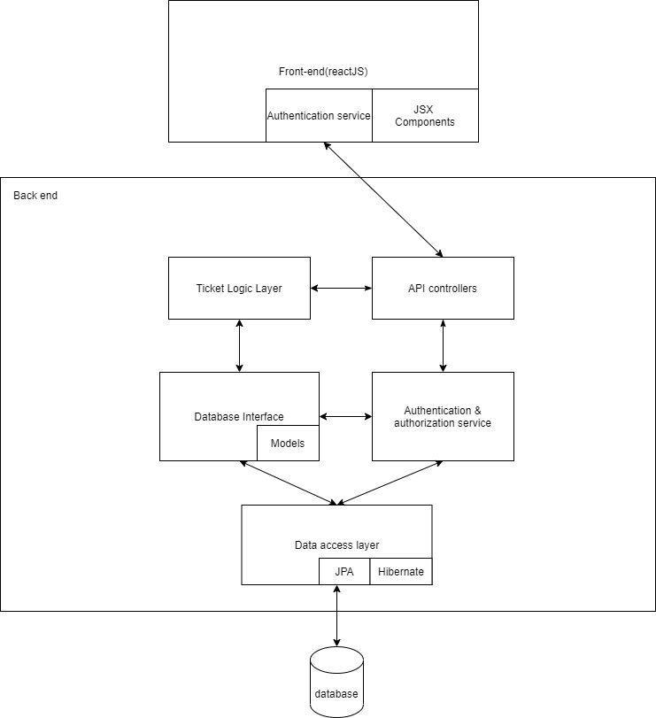

# Database Design

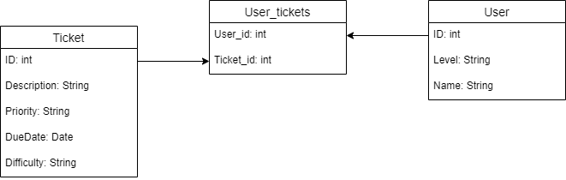

# Design Desicions

## Back-end Framework

I chose Spring boot over jersey bacause the documentation of Spring boot is way better than the documentation of jersey and moreover, Spring-boot in the most famous back end java framework ,therefore, it has a lot more resources and tutorials online.

## Front-end Framework

I chose React.js as my front end framework because it is again the most wide spread front end framework out there. It is not that hard to go into the performace in good and the syntax is elegant. There ar a lot of qualoty tutorials online for it and the documentation is ok.

# Wireframes